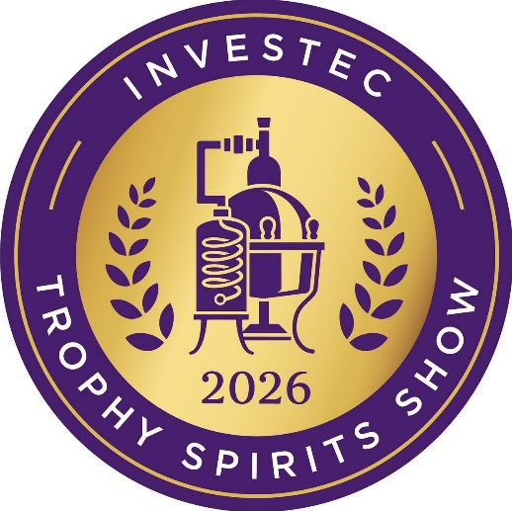

All Award Winners: Trophy, Gold, Silver, Bronze

TROPHY – A champion: highest-scoring gold medal winner in the class
GOLD MEDAL – Superlative, world-class: scored 95 to 100 out of 100
SILVER MEDAL – Excellent, spirit of distinction: scored 90 to 94 out of 100
BRONZE MEDAL – Good to very good, fine character: 85 to 89 out of 100

Trophy Winners: highest-scoring gold medallists in the class

Dullstroom Lemonlicious Limonchilli
Frapin XO Château Fontpinot Cognac
Herradura Selección Suprema Tequila
KWV XO Cellar Reserve Potstill Brandy
O'Driscolls Irish Whiskey
Redbreast 21 Year Old Irish Whiskey
Sinfonia Minor Blended Malt Scotch Whisky
Smirnoff No. 21 Vodka
Tanqueray London Dry Gin
Wild Africa Chocolate Cream

Gold Medallists: superlative, world-class

i.e. excluding trophy winners

Aberlour A'Bunadh Limited Edition Speyside Single Malt Scotch Whisky
Boschendal XO Potstill Brandy – 10 Year Old
Chivas Regal 18 Year Old Blended Scotch Whisky
Coppersmith 1904 London Dry Gin
el Jimador Reposado Tequila
KWV TEN Year Old Brandy
KWV VS Brandy
KWV VSOP Brandy
Woodford Reserve Kentucky Straight Rye Whiskey

Silver Medallists: excellent, spirit of distinction

Aberlour 12 Year Old Double Cask Matured Speyside Single Malt Scotch Whisky
Aberlour 16 Year Old Double Cask Matured Speyside Single Malt Scotch Whisky
Anarchy Dark Rum
Avante XO Cape Brandy
Avante XV Founders' Fifteen Cape Brandy
Bella Baci Arancello Liqueur
Bella Baci Limoncello
Boschendal XXO Potstill Brandy – 21 Year Old
Casamigos Blanco Tequila
Don Julio 1942 Tequila
Frapin 1270 Grande Champagne Cognac
Gordon's London Dry Gin
Imagin Classic Gin
Jameson 18 Years Irish Whiskey
Johnnie Walker Black Label Blended Scotch Whisky – Aged 12 Years
Johnnie Walker Blue Label Blended Scotch Whisky
Kavalan Single Malt Whisky
KWV FIVE Year Old Brandy
KWV THREE Year Old Brandy
Maclean's Nose Blended Scotch Whisky
Masau Golden Liqueur
Masau Spirit Aperitif
Metanoia Husk Spirit
Metanoia Klein Karoo Signature Single Malt Whisky
Metanoia Klein Karoo Signature Whisky
Redbreast 15 Year Old Irish Whiskey
Redbreast 18 Year Old Irish Whiskey
Rocco Torro American Oak Reposado – 100% De Agave Spirit
Roe & Co. Blended Irish Whiskey
Speyburn 10 Year Old Speyside Single Malt Scotch Whisky
Speyburn Bourbon Cask Speyside Single Malt Scoth Whisky
Sydney Back Potstill Brandy – 10 Years Old
Sydney Back Potstill Brandy – 25 Years Old
Tanqueray No. Ten Gin
The Glenlivet 15 Year Old Single Malt Scotch Whisky
The Glenlivet 18 Year Old Single Malt Scotch Whisky
The Glenlivet 21 Year Old Single Malt Scotch Whisky
The Singleton Single Malt Scotch Whisky – 12 Years Old
Wild Africa Café Latte Cream
Woodford Reserve Kentucky Straight Malt Whiskey

Bronze Medallists: good to very good, fine character

1320 Mellonia Honey Spirit Aperitif
Anarchy White Rum
Avante The Original VSOP Cape Brandy
Bushcraft Rum – Aged 12 Years
Cîroc Vodka
Coppersmith 1904 Berry Infused Gin
Don Julio Reposado Tequila
Dullstroom Coffee Gin
El Nativo Night Jackal Blanco – 100% Agave Spirit
El Nativo Night Jackal Reposado – Aged 100% Agave Spirit
Frapin VSOP Cognac
KWV Cruxland Gin Infused with Kalahari Truffles
KWV FIFTEEN Year Old Brandy
KWV TWELVE Year Old Brandy
Metanoia Klein Karoo VSOP Potstill Brandy 2022
Metanoia Premium Husk Spirit
Rocco Torro Blue Agave White Chocolate Liqueur
Rocco Torro French Oak Reposado – 100% De Agave Spirit
Sydney Back Potstill Brandy – 15 Years Old
Van Ryn's 10 Year Single Potstill Brandy
Van Ryn's 12 Year Single Potstill Brandy
Van Ryn's 20 Year Single Potstill Brandy
Van Ryn's 15 Year Single Potstill Brandy

ENDS

