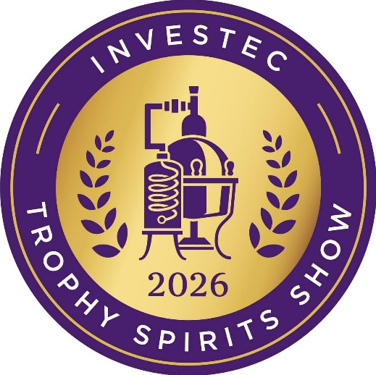

Winning Producers / Brand Owners / Agents
The full results of the 2026 Investec Trophy Spirits Show – entrants presented in alphabetical order – including the scores awarded to each spirit, judged according to a 100-point scoring system

TROPHY – A champion: highest-scoring gold medal winner in the class
GOLD MEDAL – Superlative, world-class: scored 95 to 100 out of 100
SILVER MEDAL – Excellent, spirit of distinction: scored 90 to 94 out of 100
BRONZE MEDAL – Good to very good, fine character: 85 to 89 out of 100

AVANTE BRANDY

94 Avante XO Cape Brandy
90 Avante XV Founders' Fifteen Cape Brandy
85 Avante The Original VSOP Cape Brandy

BROWN-FORMAN

96 Herradura Selección Suprema Tequila
95 el Jimador Reposado Tequila
95 Woodford Reserve Kentucky Straight Rye Whiskey
94 Woodford Reserve Kentucky Straight Malt Whiskey

LÉTALIER DISTILLERY

89 Bushcraft Rum – Aged 12 Years

DGB

96 Coppersmith 1904 London Dry Gin
95 Boschendal XO Potstill Brandy – 10 Year Old
92 Boschendal XXO Potstill Brandy – 21 Year Old
92 Sydney Back Potstill Brandy – 10 Years Old
92 Sydney Back Potstill Brandy – 25 Years Old
88 Coppersmith 1904 Berry Infused Gin
86 Sydney Back Potstill Brandy – 15 Years Old

DIAGEO SA

97 Tanqueray London Dry Gin
96 Smirnoff No. 21 Vodka
93 Don Julio 1942 Tequila
92 Casamigos Blanco Tequila
91 Gordon's London Dry Gin
90 Johnnie Walker Black Label Blended Scotch Whisky – Aged 12 Years
90 Johnnie Walker Blue Label Blended Scotch Whisky
90 Roe & Co. Blended Irish Whiskey
90 Tanqueray No. Ten Gin
90 The Singleton Single Malt Scotch Whisky – 12 Years Old
89 Don Julio Reposado Tequila
86 Cîroc Vodka

DULLSTROOM GIN

96 Dullstroom Lemonlicious Limonchilli
85 Dullstroom Coffee Gin

HEINEKEN BEVERAGES

88 Van Ryn's 10 Year Single Potstill Brandy
88 Van Ryn's 15 Year Single Potstill Brandy
87 Van Ryn's 12 Year Single Potstill Brandy
86 Van Ryn's 20 Year Single Potstill Brandy

KWV

97 KWV XO Cellar Reserve Potstill Brandy
96 Wild Africa Chocolate Cream
96 KWV TEN Year Old Brandy
96 KWV VSOP Brandy
95 KWV VS Brandy
91 Imagin Classic Gin
91 KWV FIVE Year Old Brandy
91 KWV THREE Year Old Brandy
91 Wild Africa Café Latte Cream
89 KWV Cruxland Gin Infused with Kalahari Truffles
88 KWV TWELVE Year Old Brandy
87 KWV FIFTEEN Year Old Brandy

MASAU CRAFT DISTILLERY

93 Masau Golden Liqueur
90 Masau Spirit Aperitif

METANOIA

92 Metanoia Husk Spirit
92 Metanoia Klein Karoo Signature Whisky
90 Metanoia Klein Karoo Signature Single Malt Whisky
88 Metanoia Klein Karoo VSOP Potstill Brandy 2022
88 Metanoia Premium Husk Spirit

NIGHT JACKAL DISTILLERY

93 Anarchy Dark Rum
92 Bella Baci Limoncello
91 Bella Baci Arancello Liqueur
89 El Nativo Night Jackal Reposado – Aged 100% Agave Spirit
88 Anarchy White Rum
88 El Nativo Night Jackal Blanco – 100% Agave Spirit

O’DRISCOLLS IRISH WHISKEY

96 O'Driscolls Irish Whiskey

PERNOD RICARD

96 Redbreast 21 Year Old Irish Whiskey
95 Aberlour A'Bunadh Limited Edition Speyside Single Malt Scotch Whisky
95 Chivas Regal 18 Year Old Blended Scotch Whisky
94 Aberlour 16 Year Old Double Cask Matured Speyside Single Malt Scotch Whisky
93 Redbreast 18 Year Old Irish Whiskey
93 The Glenlivet 18 Year Old Single Malt Scotch Whisky
91 Jameson 18 Years Irish Whiskey
91 The Glenlivet 15 Year Old Single Malt Scotch Whisky
91 The Glenlivet 21 Year Old Single Malt Scotch Whisky
90 Aberlour 12 Year Old Double Cask Matured Speyside Single Malt Scotch Whisky
90 Redbreast 15 Year Old Irish Whiskey

PREMIER PURE FUSION

89 1320 Mellonia Honey Spirit Aperitif

RECIPROCAL WINES

96 Frapin XO Château Fontpinot Cognac
90 Frapin 1270 Grande Champagne Cognac
88 Frapin VSOP Cognac

ROCCO TORRO

91 Rocco Torro American Oak Reposado – 100% De Agave Spirit
88 Rocco Torro French Oak Reposado – 100% De Agave Spirit
86 Rocco Torro Blue Agave White Chocolate Liqueur

UNIVERSAL BEVERAGES

93 Maclean's Nose Blended Scotch Whisky
91 Kavalan Single Malt Whisky
91 Speyburn 10 Year Old Speyside Single Malt Scotch Whisky
90 Speyburn Bourbon Cask Speyside Single Malt Scoth Whisky

WHISKYBROTHER

97 Sinfonia Minor Blended Malt Scotch Whisky

ENDS

