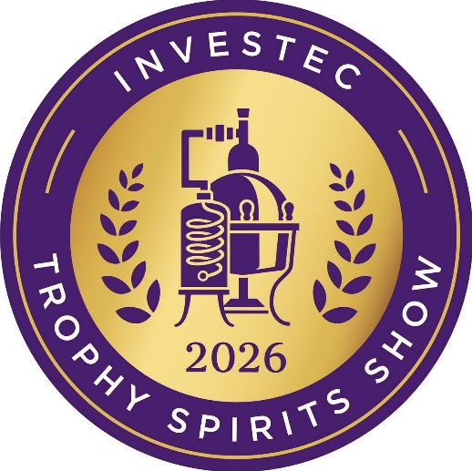
Trophy Winners

Trophy for Best Potstill Brandy
Investec Trophy for Best Brandy of Show
KWV XO Cellar Reserve Potstill Brandy

Investec Trophy for Best Malt Whisky
Investec Trophy for Best Whisky of Show
Sinfonia Minor Blended Malt Scotch Whisky

Investec Trophy for Best London Dry Gin
Riedel Trophy for Best Gin of Show
Tanqueray London Dry Gin

Trophy for Best Cognac
Frapin XO Chateâu Fontpinot Cognac

Trophy for Best Vodka
Smirnoff No. 21 Vodka

Investec Trophy for Best Single Potstill Whisk(e)y
Vinolok Trophy for Best Premium Spirit
Redbreast 21 Year Old Single Potstill Irish Whiskey

Investec Trophy for Best Blended Whisk(e)y
O'Driscolls Irish Whiskey Matured in Bourbon Cask

Trophy for Best Tequila
Herradura Selección Suprema Tequila

Trophy for Best Aperitif
Dullstroom Lemonlicious Limonchilli

Trophy for Best Liqueur
Wild Africa Chocolate Cream

Gold Medal Winners

Aberlour A'Bunadh Speyside Single Malt Scotch Whisky
Boschendal Potstill Brandy XO – 10 Year Old
Chivas Regal 18 – Aged 18 Years
Coppersmith 1904 London Dry Gin
el Jimador Reposado Tequila
KWV TEN Year Old Brandy
KWV VS Brandy
KWV VSOP Brandy
Woodford Reserve Distiller’s Select Kentucky Straight Rye Whiskey

Silver Medal Winners

Aberlour Speyside Single Malt Scotch Whisky 12 year Old Double Cask Matured
Aberlour Speyside Single Malt Scotch Whisky 16 year Old Double Cask Matured
Anarchy Premium Dark Rum
Avante XO Cape Brandy
Avante XV Founders' Fifteen Cape Brandy
Bella Baci Arancello Liqueur
Bella Baci Limoncello
Boschendal Potstill XXO Brandy 21 Year Old
Casamigos Blanco Tequila
Don Julio 1942 Tequila Anejo
Frapin Grande Champagne Cognac 1270
Gordon's Special London Dry Gin
IMAGIN Original London Dry Gin Classic Juniper
Jameson Triple Distilled Blended Irish Whiskey 18 year Old
Johnnie Walker Black Label 12 Year Old Blended Scotch Whisky
Johnnie Walker Blue Label Blended Scotch Whisky
Kavalan Lán Single Malt Whisky
KWV THREE
KWV FIVE
Maclean's Nose Blended Scotch Whisky
Masau Spirits Golden Liqueur
Masau Wooded Cane Spirit Aperitif
Metanoia Husk Spirit
Metanoia Klein Karoo Signature Single Malt Whisky
Metanoia Klein Karoo Signature Whisky
Redbreast 15 Year Old Single Potstill Irish Whiskey
Redbreast 18 Year Old Single Potstill Irish Whiskey
Rocco Torro Reposado 100% De Agave Spirit
Roe & Co. Blended Irish Whiskey
Speyburn Bourbon Cask Speyside Single Malt Scotch Whisky
Speyburn Speyside Single Malt Scotch Whisky aged 10 Years
Sydney Back Finest Matured Potstill 10 Year Old Brandy
Sydney Back Limited Reserve Potstill 25 Year Old Brandy
Tanqueray No. Ten
The Glenlivet 15 Year Old
The Glenlivet 18 Year Old
The Glenlivet 21 Year Old
The Singleton of Dufftown Luscious Nectar 12 Years Old
Wild Africa Café Latte Cream
Woodford Reserve Distiller's Select Kentucky Straight Malt Whiskey

