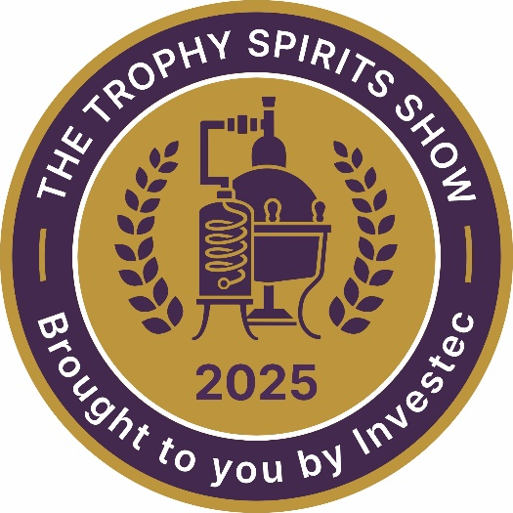

THE TROPHY SPIRITS SHOW brought to you by Investec

Media Release – embargoed until Thursday 19 June at 20h30

Strength in Diversity

TSS Release 2025.1

The Trophy Spirits Show – brought to you by Investec – is a unique competition in the South African spirits industry: the breadth and depth of what it examines, assesses and rewards is quite unlike any other such competition and unparalleled in this country. It is defined by the judging methodology first developed at the Trophy Wine Show and now widely emulated. However, the diversity of categories, ranging from South Africa’s pot-still brandy industry (which traces its origins back to the 17th century), via local and international gin, liqueurs, agave (tequila), vodka and spirit aperitifs to the finest malt and blended whiskies produced in Scotland and Ireland gives it a very special quality.

Now in its 7th successive year, the Trophy Spirits Show sees Cape brandy confronting the best French cognacs in one of the only competitions of its kind where all pot-distilled grape products are judged in the same class; gins from major producers around the world go head-to-head with craft distillates made by local artisans, while in the whisky classes the best of malts and blends from Scotland take on the finest pot-distillates from across the Irish Sea. The fact that so many South African brands emerged victorious at the end of the day’s judging speaks of the quality of craftsmanship built up over many generations – and dating back to the first recorded spirit production in South Africa in 1679. As with our rugby and test cricket teams, our spirits creators punch way above their size and weight.

The 2025 edition of the competition saw more entries than in 2024. It is clear that the producers and importers of high-end products have come to trust the panels which sit in judgement of their spirits and liqueurs.

There were 111 entries received this year from 28 producers and distributors with 60 brands, spread through 19 categories. In terms of total entries, the whisk(e)y classes saw the greatest number viz. 34. Included in this line-up were malt, pot-still and blended whiskies/whiskeys. It is a tribute to the respect in which the show is held that most of the major brands were
TSS Release 2025. 2

represented. The gin classes saw a fair spread of entries across all three categories – London Dry, Distilled and Flavoured Gin, and included local craft submissions as well as entries from many of the international producers. Brandy was well represented with pot-still submissions from the Cape and France.

Unsurprisingly, given the worldwide surge in interest in tequila/agave and rum, there was good representation in these classes, while vodkas and cream liqueurs completed the judging line-up.

Speaking on behalf of Investec, Peta Dixon, Head of Sponsorship at the bank said: “Investec is proud to sponsor the Trophy Spirits Show, which showcases South Africa’s top distillers on an international platform. This competition highlights the quality and craftsmanship of our local spirits and reinforces our commitment to supporting the growth and excellence of the industry."

As in previous years, entries came in from producers in places as far afield as England, Ireland, the highlands of Scotland, the deserts of Mexico and the villages of Cognac, France. Included among these exotics were at least 60 different brandies, liqueurs, whiskies and gins from the Cape, Gauteng and Mpumalanga. South Africa's share of the gold medals and trophies was significant enough to serve as a tribute to the craft and skill of our domestic distillers, and a vindication of Investec’s commitment to an industry which makes a major contribution to employment and to the country’s GDP.

The teams on the tasting benches comprised three senior judges, together with an associate whose input is noted but not necessarily taken into account in the final tally. The panellists were as follows: Andy Watts, Jason McEvoy, Dave Gunns, Dr Mare-Loe Prinsloo, Carla Weightman, Sean Gunns, Kresan Naidu, Dr Winnie Bowman CWM and Kurt Schlechter.

The associate judges were Matthew Cox, Anriënka Vlok van Zyl and Sulette Oelofse. Show convenor Michael Fridjhon was Chairman of the Judges.

All results, including silver (90 to 94/100) and bronze medallists (85 – 89/100), are listed on the
website: https://trophyspiritshow.co.za/winners-and-results/

The Results

Trophy Winners

Investec Trophy for Best Malt Whisky
Investec Trophy for Best Whisky of Show
Benriach Smoke Season Single Malt Scotch Whisky - Double Cask Matured

Trophy for Best Pot-distilled Brandy
Investec Trophy for Best Brandy of Show
Avante Founders' Fifteen Cape Brandy

Investec Trophy for Best London Gin
Riedel Trophy for Best Gin of Show
Ginologist Handcrafted Small Batch London Dry Gin

Investec Trophy for Best Tequila
Vinolok Trophy for Best Premium Spirit
Don Julio 1942 Tequila Anejo

Investec Trophy for Best Blended Whisky
Johnnie Walker Black Label Blended Scotch Whisky Aged 12 Years

Investec Trophy for Best Distilled Gin
Emperor Gin

Investec Trophy for Best Single Pot Still Whisk(e)y
Yellow Spot Single Pot Still Irish Whiskey Aged 12 Years

Investec Trophy for Best Liqueur of Show
Wilderer Rogue Apple Pie Moonshine

Trophy for Best Flavoured Gin
Inverroche Verdant Gin

Trophy for Best Vodka of Show
Circa 1430 Vodka

Trophy for Best Aperitif
Dullstroom Lemonlicious LemonGinCello

Trophy for Best Grappa
Wilderer Pinotage Grappa

Gold Medal Winners

Aberlour Speyside Single Malt Scotch Whisky 12 Year Old
Chivas Regal Gold Signature Blended Scotch Whisky Aged 18 Years
Espolòn Tequila Blanco
Espolòn Tequila Reposado
KWV 15 Year Old Potstill Brandy – Alambic Blend
KWV XO Potstill Brandy – Cellar Reserve
Lagavulin Special Release Islay Single Malt Scotch Whisky 12 Year Old
McConnell's 20 Year Old Port Finish Single Malt Irish Whisky - Whisky Brother Excl
Redbreast 12 Year Old Single Pot Still Irish Whiskey
Tanqueray London Dry Gin
The Singleton Glen Ord 14 Years Old Special Release Single Malt Scotch Whisky
Wilderer Muscato Grappa

ends
Issued by OutSorceress Marketing on behalf of The Trophy Spirits Show brought to you by Investec
Contact: Janice Fridjhon or Alex Mason-Gordon
Email: janice@outsorceress.co.za or trophy@outsorceress.co.za
Tel: 083 302 2197 or 083 308 1447
Contact: Michael Fridjhon, Chairman of the Judges
Email: mf@reciprocal.co.za
Tel: 011 482 9178 or 083 600 9101
Contact: Caitlin Robertson
Investec Group Marketing
Email: caitlin.robertson@investec.com
Issued: 19 June 2025
WEBSITE: https://trophyspiritshow.co.za/

