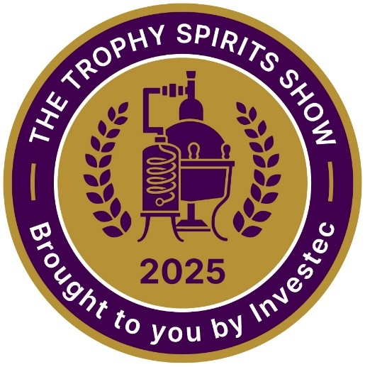

Trophy Winners

Investec Trophy for Best Malt Whisk(e)y
Investec Trophy for Best Whisk(e)y of Show
Benriach Smoke Season Single Malt Scotch Whisky - Double Cask Matured

Trophy for Best Pot-distilled Brandy
Investec Trophy for Best Brandy of Show
Avante Founders' Fifteen Cape Brandy

Investec Trophy for Best London Gin
Riedel Trophy for Best Gin of Show
Ginologist Handcrafted Small Batch London Dry Gin

Investec Trophy for Best Tequila
Vinolok Trophy for Best Premium Spirit
Don Julio 1942 Tequila Anejo

Investec Trophy for Best Blended Whisk(e)y
Johnnie Walker Black Label Blended Scotch Whisky Aged 12 Years

Investec Trophy for Best Distilled Gin
Emperor Gin

Investec Trophy for Best Single Pot Still Whisk(e)y
Yellow Spot Single Pot Still Irish Whiskey Aged 12 Years

Investec Trophy for Best Liqueur of Show
Wilderer Rogue Apple Pie Moonshine

Trophy for Best Flavoured Gin
Inverroche Verdant Gin

Trophy for Best Vodka of Show
Circa 1430 Vodka

Trophy for Best Aperitif
Dullstroom Lemonlicious LemonGinCello

Trophy for Best Grappa
Wilderer Pinotage Grappa

Gold Medal Winners

Aberlour Speyside Single Malt Scotch Whisky 12 Year Old
Chivas Regal Gold Signature Blended Scotch Whisky Aged 18 Years
Espolòn Tequila Blanco
Espolòn Tequila Reposado
KWV 15 Year Old Potstill Brandy – Alambic Blend
KWV XO Potstill Brandy – Cellar Reserve
Lagavulin Special Release Islay Single Malt Scotch Whisky 12 Year Old
McConnell's 20 Year Old Port Finish Single Malt Irish Whisky - Whisky Brother Excl
Redbreast 12 Year Old Single Pot Still Irish Whiskey
Tanqueray London Dry Gin
The Singleton Glen Ord 14 Years Old Special Release Single Malt Scotch Whisky
Wilderer Muscato Grappa

